Family and Friends Service Satisfaction Questionnaire 2022 (The Pines Home Care)

Publish analytics

(Q1/9) HOW HAPPY DO YOU FEEL YOUR FAMILY MEMBER IS WITH THE PINES HOME CARE SERVICE?7 responses

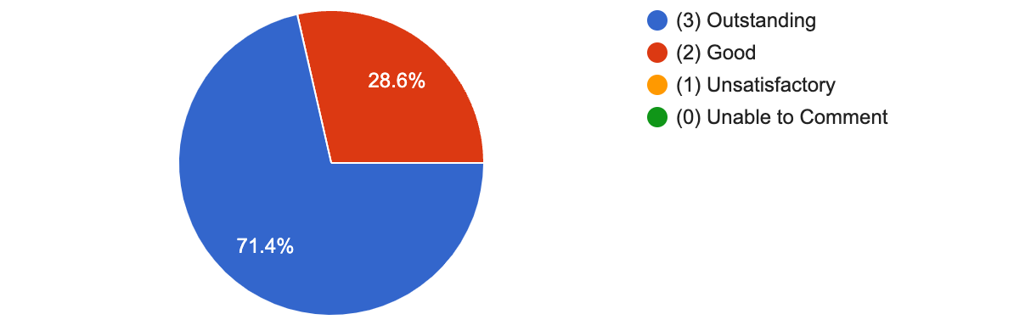

- Matthew regards you all as his "extended family". Lovely.
- Better and regular communication of staff rotas would help more
- A great service, my family member lives a fulfilled and meaningful life and very happy.
- I feel that Alex is very happy with the wonderful service
- He is very happy with the care he receives
- The behaviour of one of the other housemates appears to have led to a less enjoyable experience than before.
- He is very happy. He calls it his forever home

(Q2/9) HOW DO YOU FEEL WE RESPONDED TO THE COVID 19 PANDEMIC?7 responses
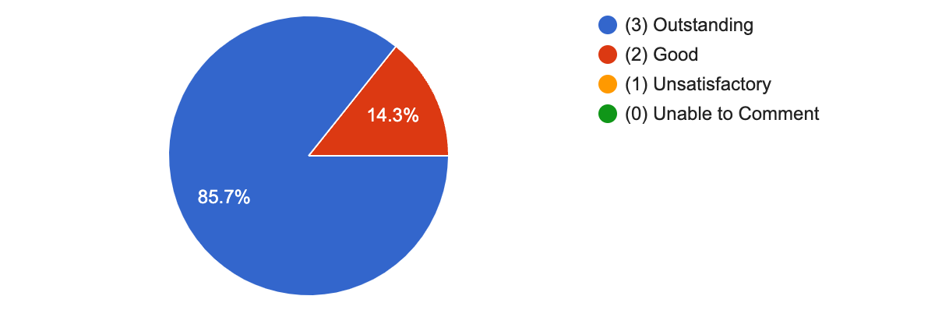
- My family member was kept safe at all times, remained with the same staff team who continually wore protective equipment.
- Very well
- Effectively whilst providing high level of care
- It would appear that challenges in connection with isolation, communication, PPE and staffing levels were dealt with well to ensure staff and resident safety. I commend all staff for their efforts to ensure residents were safe and supported.

(Q3/9) HOW WELL DO WE DEAL WITH COMPLAINTS?7 responses

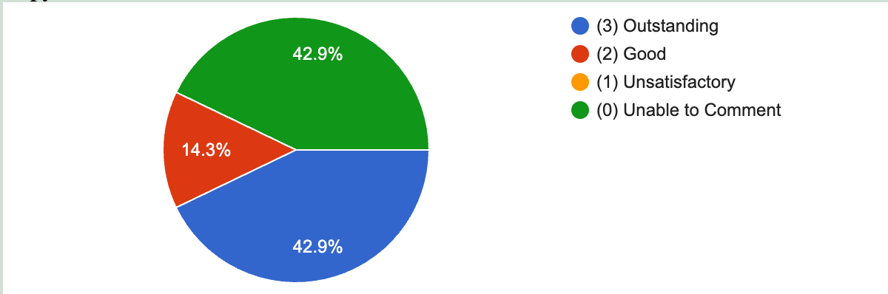
- You need another question inserted before 3/9! "Have you made any complaints in the last year?" I don't think I have? Most things we communicate are just little tweaks to things.
- I have never had to complain, I have raised a couple of issues/queries and they were addressed and dealt with immediately.
- I have never had any complaints, but I am sure they would be attended to perfectly
- Only minor issues and dealt with effectively

(Q4/9) HOW HAVE YOU FOUND THE ATTITUDE OF THE STAFF AT THE PINES HOME CARE?7 responses

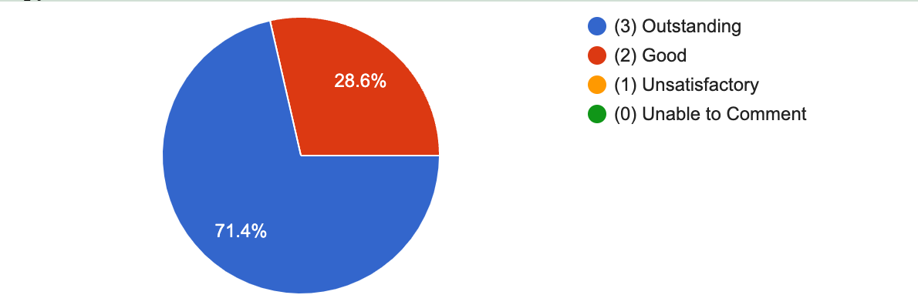
- Best Matthew has ever had.
- Can't fault them, very positive and caring attitudes.
- Everyone has been exceptionally kind to us.
- Very positive and professional
- I've always found staff friendly and helpful
- Everyone’s very kind and caring and also proactive about trying new things

(Q5/9) WOULD YOU DESCRIBE THE STAFF AS CARING?7 responses
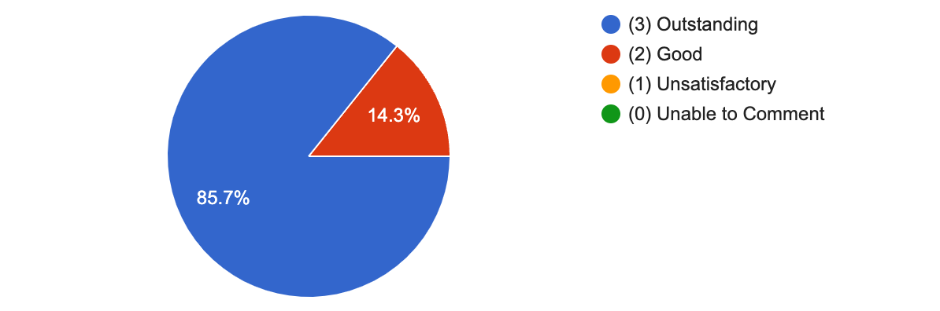
- Very, they always put the needs of my family member first.
- They are really kind and caring, and we are very grateful
- Extremely
- Staff were very supportive to enable Naomi to be fully prepared to go on holiday

(Q6/9) HOW SAFE DO YOU FEEL YOUR FAMILY/FRIEND IS IN OUR CARE?7 responses
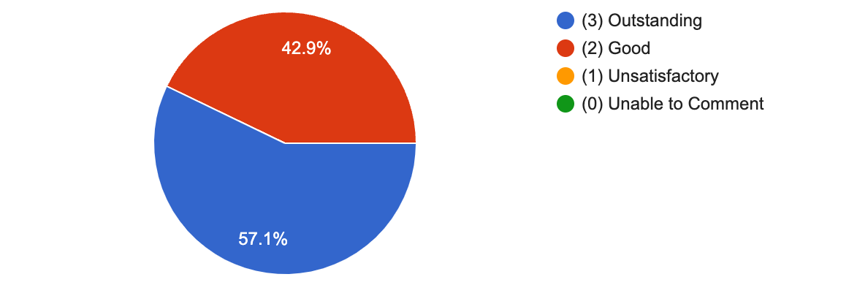

- Very safe, you were wonderful during Covid!
- Very safe
- I feel very confidant in their care.
- The landlord has still not replaced the key lock with a thumb lock on the front door. A reminder email was sent by me 12 months ago. The lesser ability of current residents makes this even more of a safety issue. (Worst case scenario: fire in the kitchen, need to escape via the front door, can't find the key to unlock it).

(Q7/9) HOW WELL DO YOU FEEL THE INDIVIDUAL NEEDS AND WISHES OF YOUR FAMILY/FRIEND ARE CATERED FOR?7 responses

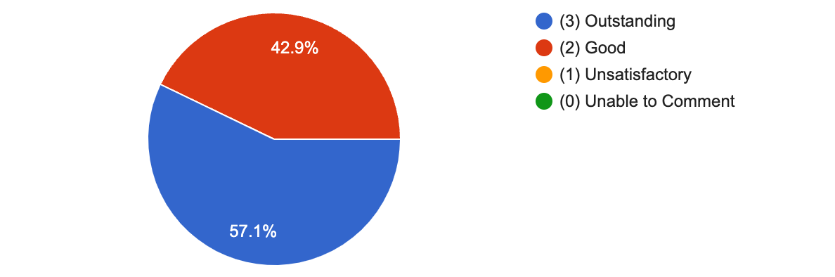
- As I get older, I'd like staff to be a bit more imaginative about days out etc. There is no reason why Matt can't go somewhere really interesting every weekend, apart from someone to organise it. I'd like someone to have a specific "housemother" type role, to plan things, especially as Matt loves going places BUT cannot bring them to mind easily or name them because of his disability. Matthew told me he had too much stuff in his cupboards last weekend and said he wanted to send some stuff to Sue Ryder's. Further investigation revealed LOTS of stuff that I'd given him with food in them on trips home, and he hadn't given them back to me!!! I brought a boxful back home. I'd also like someone to support him more with his cupboards, so that person can tell me for example if he needs more shorts or a new chest of drawers - I was told he needed both last year, and arranged them, only to find shorts in 4 different places and some empty underbed drawers!!! I'd also like someone to take charge of the sheds and their contents, and dealing with Martins.
- The management and staff team are always striving to meet the needs and will regularly communicate with me to suggest good ideas to go above and beyond what is required.
- I feel they do everything they can to meet Alex's wishes
- Pines staff go out there way to fulfil his needs and wishes.
- I welcomed the intervention to manage Naomi's room tidying, but the plans seem to have slipped - perhaps because of continuity issues and unavoidable staff issues? There is a significant need to prevent clutter gathering and remove items to charity. Naomi's carer offers a good balance between kind support and pragmatic guidance.

(Q8/9) HOW WELL DOES THE MANAGEMENT TEAM SUPPORT YOU AND YOUR FAMILY/FRIEND?7 responses
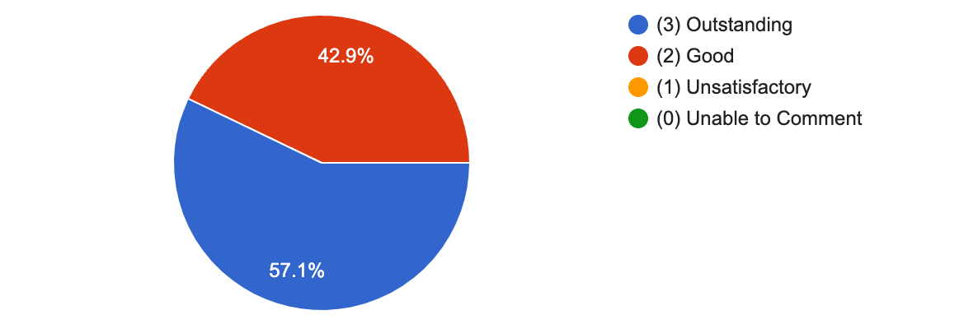

- Matt is very happy at his flat, it's always clean and tidy. Someone with a housemother role would be helpful as I seldom visit the flat. Matt told me at the weekend that his sink has been leaking into his cupboard for years, but he didn't tell anyone. I only found out by chance last weekend.
- Always there to answer a question
- We communicate via email and telephone, fully supported by the management team.
- I think we are very lucky to be able to have our son there and he is perfectly supported.
- The management team are extremely supportive and professional
- Any queries are quickly responded to and usually dealt with. Issues raised regarding a 'boyfriend' were diplomatically handled.

(Q9/9) HOW DO YOU RATE THE OVERALL LEVEL OF CARE PROVIDED BY THE PINES HOME CARE?7 responses
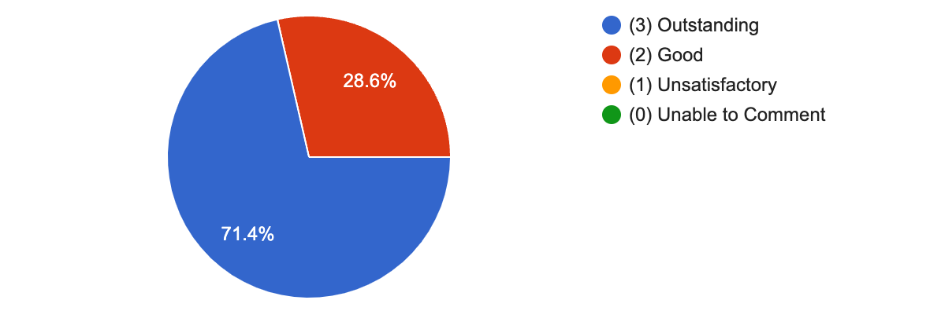

- As a 70 years old slightly disabled parent, it's lovely being able to trust you all to look after Matt when for health reasons, I can't.
- I would not want my family member to be supported by any other company.
- As I have written, I know how lucky we are that our son is there especially as we are a long way away..
- We can not fault the care our son has received from The PinesHomeCare over the last 12yrs
- Basic skills regarding the management of the physical aspects of the house seem to be slipping. Windows are rarely opened; radiators are fully open; the washing bowl appears never to be removed and the kitchen sink cleaned; I'm informed that the shower plug hole apparently becomes blocked regularly; and the same rubbish has been left for weeks outside the front door. Broken wheelie bins have not been replaced. Having to physically secure personal food items to prevent unauthorised use is unfortunate.
- Any final comments? This form is completely anonymous unless you add your name here (in which case you consent to being contacted about your answers). Thanks!5 responses
- Thank you, thank you, thank you.
- I would like to thank The Pines management and the staff for all that they do. I never have to worry about my family member and know that he is living the best possible life. Thank you
- Mrs Gillian Griffith (Alex Hathorn's Mum)
- Our son is able to live a happy, fulfilled and independent life due to the outstanding level of care and support provided by The PinesHomeCare. Sandra Suttle
- No decoration has taken place since the house was let. The leak patch on the ceiling above Naomi's wardrobe seems to be getting bigger, the window cill in the downstairs loo is rotting, blinds are broken where they have not been lifted to open a window, the coat hanger has not been replaced and some walls need repainting. Phil Allen

