Staff Satisfaction Questionnaire 2022
(The Pines Home Care)

Publish analytics

(Q1/10) HOW DO YOU RATE THE TRAINING YOU RECEIVE AT THE PINES HOME CARE?
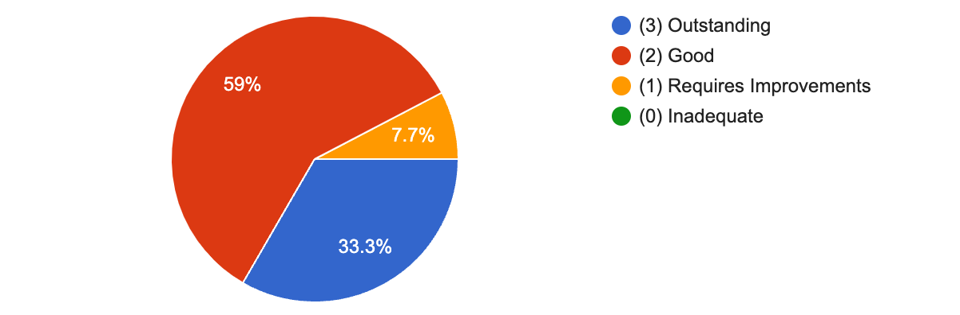

(Q1A/10) DO YOU HAVE ANY COMMENTS ABOUT THE TRAINING YOU RECEIVE AT THE PINES HOME CARE?

- No
- The Pines are always making sure my training is up-to-date.
- Really enjoy the training
- Maybe more classroom
- It’s good training
- Like that it is online training
- The training was informative and helped a lot to prepare for the day to day work. I would have appreciated if there was an extra day to understand different learning disabilities as well as maybe an induction in sign language
- Mainly experienced online training mainly because of Covid. Decent level of training.
- The online training is not comprehensive enough.
- All good and appropriate
- More in person training would be beneficial
- Should be geared more for supported living some of the things are geared for care homes

(Q2/10) HOW DO YOU RATE THE SUPERVISION YOU RECEIVE?

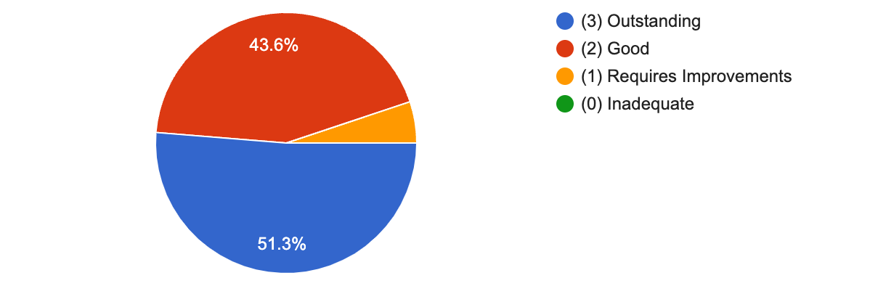

(Q2A/10) DO YOU HAVE ANY COMMENTS ABOUT THE SUPERVISION YOU RECEIVE?

- No
- Management always listen to my suggestions and try to support me wherever they can. They are very constructive with their feedback. I feel that I can contact them at any time if I need to.
- The Pines always give me good feedback on my supervisions.
- Very supportive and caring
- Regular supervisions carried out either in person or over the phone
- Always know I can request a supervision at any time
- All good. Appreciated the positive feedback
- My supervision session received have always been thorough and regular.
- When we can return to face to face supervisions this will be better.
- Great
- Management there when you need then. Random spot checks could improve staff performance
- Thank you very much for listening and taking any issues seriously
- Supervisions can feel rushed a times.
- No

(Q3/10) HOW SUPPORTED DO YOU FEEL BY MANAGEMENT WITH REGARD TO PERSONAL ISSUES?

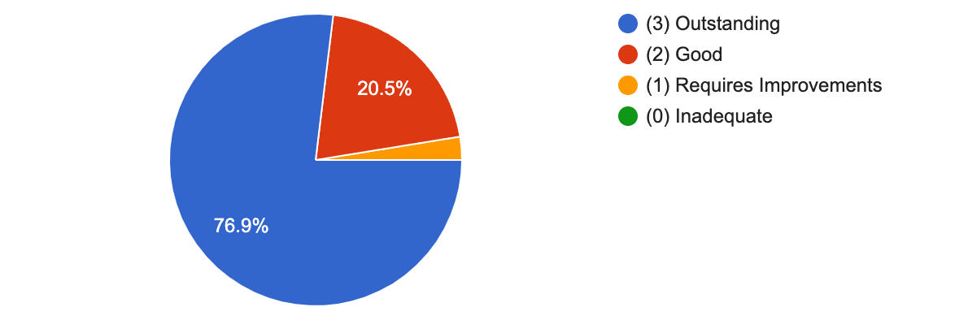

(Q3A/10) DO YOU HAVE ANY COMMENTS ABOUT THE SUPPORT YOU RECEIVE WITH REGARD TO PERSONAL ISSUES?

- No
- Very flexible, understanding and caring.
- Very supportive when I was off sick
- Always able to discuss any personal issues with My manager
- The Pines are always there to listen to any personal issues I may have.
- Very understanding
- Management always very supportive with my health issues
- Management were very empathetic towards personal issues I had in the past when my elderly mother was unwell , gave my time off / switched my shifts last minute .
- Management always adapt my shifts when I have an issue with my child .
- Always feel listened to. Issues are quickly resolved if I have any.
- I am very grateful about how understanding and accommodating everyone in the office is. This makes a huge difference to all my employers before
- I have always over a number of years experienced support by the management, which has been appreciated.
- I know that I can contact the management and any issues will be dealt with appropriate to me.
- Total support as always
- Thank you very much x
- I feel sometimes the management can overlook that staff may have personal issues going on with their rushed approach. I also do not feel management are aware of a lot of issues that go on, (understandably if they are not told), but sometimes their approach can really add to stressful life events staff are already experiencing.
- Management have always been there for me when I needed them to be.

(Q4/10) HOW HAPPY ARE YOU WITH YOUR WORK RESPONSIBILITIES?

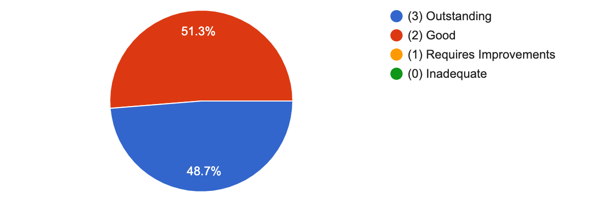

(Q4A/10) DO YOU HAVE ANY COMMENTS ABOUT YOUR WORK RESPONSIBILITIES?

- No
- The Pines are always there to help with any responsibilities I find difficult.
- Happy with current responsibilities
- Never feel I am put under any pressure
- Really like my job and the clients I support
- I am very grateful to be able to work alone already and appreciate the trust
- I was happy to support one of my service users to go to London for a few days away last year.
- It would be nice if keyworkers received additional pay. Pro rata bonus was greatly appreciated.

(Q5/10) DO YOU FEEL SUPPORTED BY THE OUT OF HOURS MANAGEMENT TEAM?
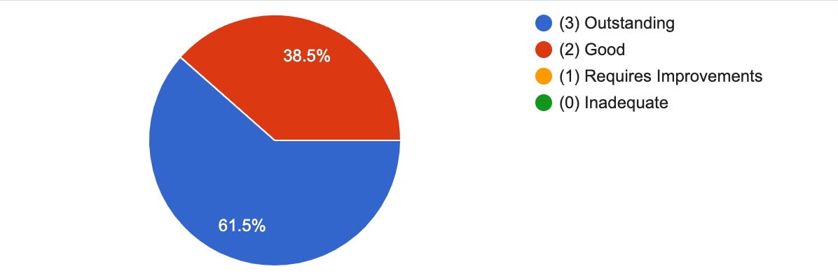

(Q5A/10) DO YOU HAVE ANY COMMENTS ABOUT THE OUT OF HOURS MANAGEMENT TEAM?

- No
- I receive the same high level of support in and out of office hours.
- All management team know all the clients well
- Yes the out of hours team are always supportive with me.
- It is great to know that the out of hours team are there for support
- They are always contactable 24/7
- Always contactable morning , noon and night
- Always on the other end of the phone and manager always available for extra support
- Very rarely had to call but never had any issues.
- I have not used it yet
- I have personally rarely used the on call system, but I know that someone is always available 24 hours.
- Always answer any questions promptly
- I know that if I need to contact or speak to someone they will always be available or reply asap.
- Never an issue

(Q6/10) DO YOU FEEL THE MANAGEMENT ARE RESPONSIVE TO YOURSELF?

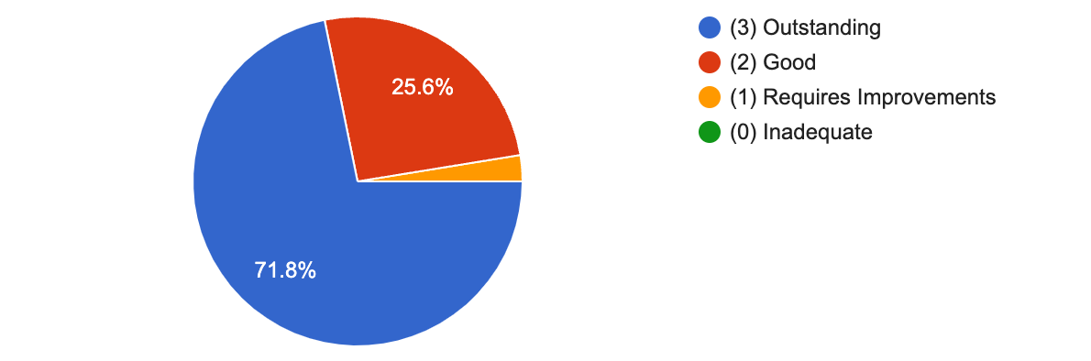

(Q6A/10) DO YOU HAVE ANY COMMENTS ABOUT MANAGEMENT'S RESPONSIVENESS?

- No
- Very responsive
- Always quick to respond and helpful
- Have always responded
- The management always respond to any questions I may have.
- They respond well to all my questions and queries
- Manager is always responsive to any queries I have had
- 100% responsive
- Always hear back from them very quickly
- There is always a reply to every request and it usually comes very quickly
- I have experienced the management to always be very fast and responsive to concerns that I have had.
- Marie has always helped with any questions I have had quickly.
- I feel that the management are always willing to go the extra mile for those who put in extra effort/hours.
- Thank you:-)
- Often have in the past be not replied to. This can lead to staff being unsure what they are doing, and feeling unsupported.

(Q7/10) HOW DO YOU RATE THE CARE WE GIVE AT THE PINES HOME CARE?
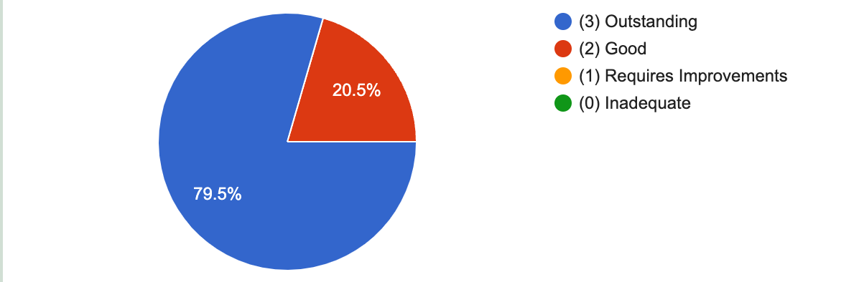

COMMENTS ABOUT THE CARE WE GIVE AT THE PINES HOME CARE?

- No
- If one of my family required support, I would definitely choose The Pines to support them.
- Always evolve and adapt to changes well, making sure client's needs are met
- The Pines care is great from all staff members.
- The clients are very well supported
- Very personable to the clients
- All my colleagues I work with give excellent care and really care about their service users
- I think the care is great and very person centred for each individual
- I know through working various roles that genuine Care is the main driving force of the business.
- Great Team and great care provided.
- Some staff are excellent and some appear to do the bare minimum.
- Excellent organisation,caring /expert management team

(Q8/10) HOW WELL DO YOU FEEL YOUR INPUT IS RECEIVED AND ACTED UPON?
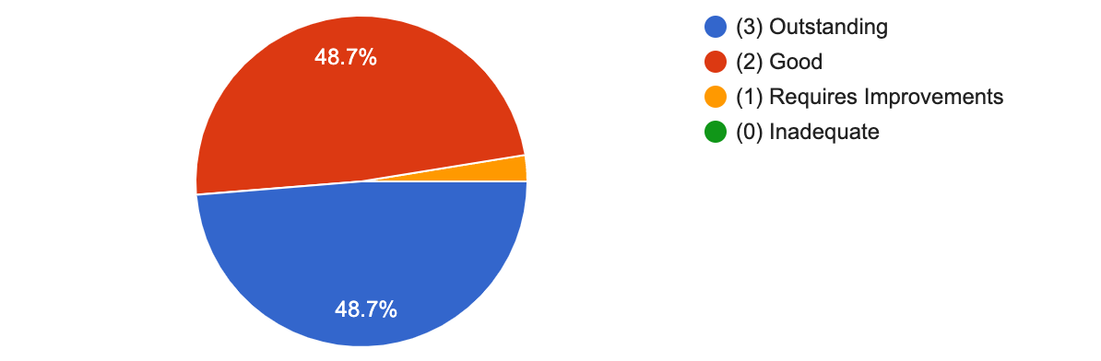

(Q8A/10) DO YOU HAVE ANY COMMENTS ABOUT HOW WELL YOUR INPUT IS RECEIVED AND ACTED UPON?

- No
- My input is always received well and acted upon straight away.
- All of my concerns with regard to the package that I work in have been listened to and acted upon.
- I feel that the manager makes every attempt to listen and support staff to the best they can.
- Concerns do not always appear to be followed up

(Q9/10) HOW WELL DO YOU FEEL YOU ARE SUPPORTED BY THE MANAGER WHILST YOU ARE IN THE COMMUNITY?39 responses

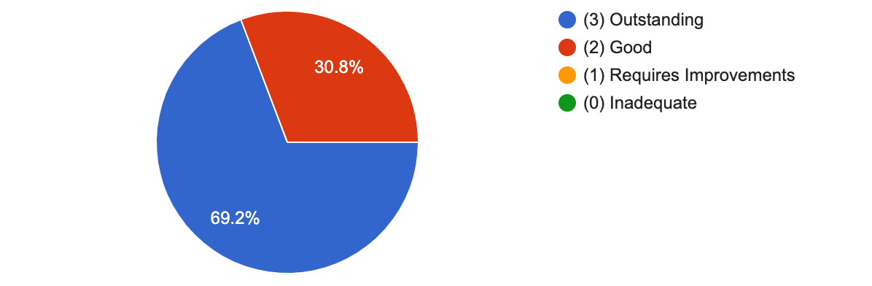

(Q9A/10) DO YOU HAVE ANY COMMENTS ABOUT BEING SUPPORTED BY THE MANAGER WHILST YOU ARE IN THE COMMUNITY?

- No
- The management always support over the phone or in person if needed.
- Again very approachable , willing to step in if any difficulties.
- My manager and the team are always available for support if I need it
- 100 percent supported by the management team
- Manager always to hand
- No all good
- I know there’s always someone I can contact if I need to
- I know that the management are always available if needed.
- I know that someone is always on the end of the phone.
- No

(Q10/10) WOULD YOU BE HAPPY FOR YOUR FAMILY TO USE OUR SERVICE?

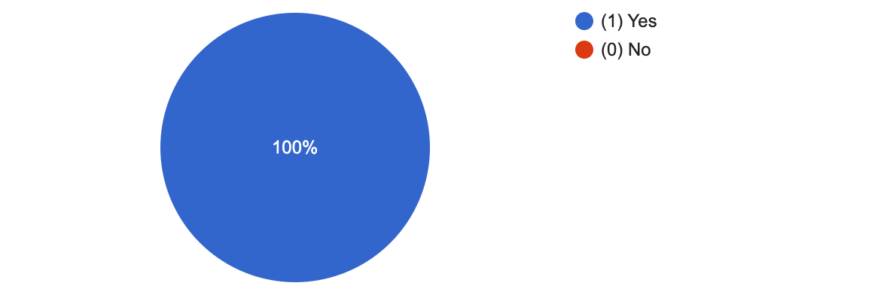

(Q10A/10) PLEASE GIVE YOUR REASONS FOR ANSWERING YES OR NO TO QUESTION 10 (WOULD YOU BE HAPPY FOR YOUR FAMILY TO USE OUR SERVICE?)

- Because they would receive the best care possible.
- I feel the quality if care given is of a high standard, good staff and good management
- Very caring towards clients and staff
- I would be happy for any member of my family to use The Pines service.
- Because I know they would be very well looked after
- I feel the staff are genuinely caring and kind people.
- No
- Good level of care.
- I feel the carers and management are kind people and would not hesitate in using them
- Staff and management really care about their service users
- In general good company
- Because all the service users I have supported are settled and extremely happy
- It’s a good company to work for as well as being care for
- Yes definitely
- The pines are always working hard to make sure no one is left without care
- If anyone ever needed support in my family I would love it to be with the Pines as I know they’d be in good hands
- I feel that service users are supported by The Pines Home Care fairly with a genuine care and support ethos and not just a service for sheer profit.
- An excellent care service is provided by the pines. I've worked for others in the past and believe the Pines to be one of the better care providers out there.
- Some staff are very caring and professional others don't really go out of their way to make it person centred.
- Person centred, caring, always wanting what’s best for the well being of the client
- Could not imagine a better company to be involved in.
- I do appreciate management and most of my co workers, their attitude and carying nature. Most of us are passionate and really care about our aervice users.
- I think they have good standards
- Any final comments? This form is completely anonymous unless you choose to add your name here (in which case you consent to being contacted about your answers). Thanks!14 responses
- No
- The Pines are the best company to work for. They actually care about their staff and clients, they will always put themselves out for us, they are flexible, professional, full of integrity and honest.
- Excellent company to work for , look after their staff very well .
- I enjoy working for the pines
- None
- Best company I have worked for and have worked for a few ! Thanks
- Love working for the pines
- Thank you for being such a good employer. I really like working for you :) Helen Anderson
- I am very happy and I do enjoy going to work. Thank you so much for being accommodating and flexible. This means a lot - especially as a new parent. I do enjoy my work with each individual and it’s so lovely to see them thrive.
- Thank you for all the support that you have shown me over many years.
- Jamie
- Some notes on Nourish are completely inadequate and are not a true account of what was done during the session. Maybe training on writing notes for some staff would be beneficial.
- In terms of support for clients, I believe there is lots in place to ensure its at its best standard. However, sometimes the approach from management can be abrupt and not supportive. I and I know others have felt sometimes how staff are spoken to or messages received are slightly unprofessional which leads staff to feeling they are unable to approach the management team when needed in terms of personal issues.

